CS624 Full Stack Development – Mobile App
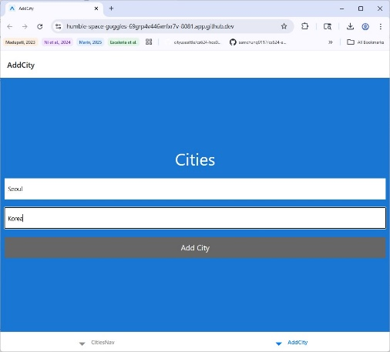
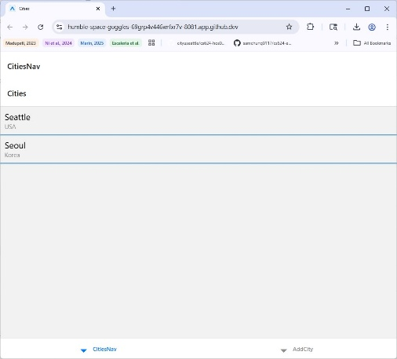
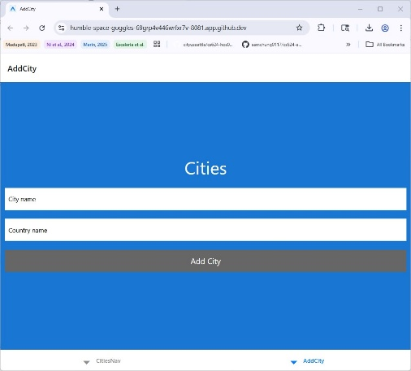
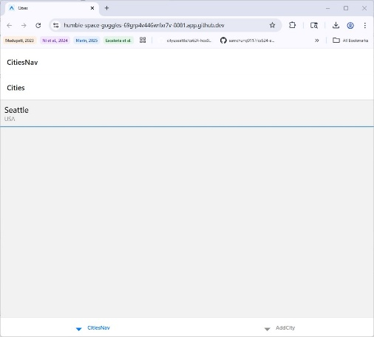
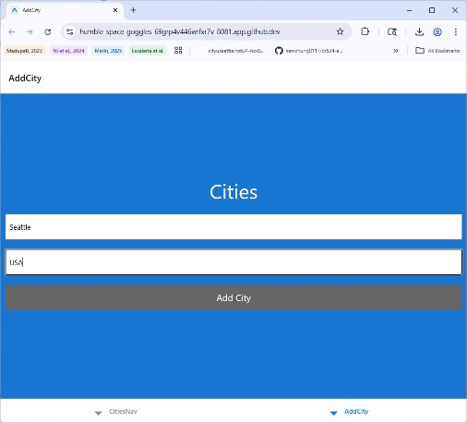
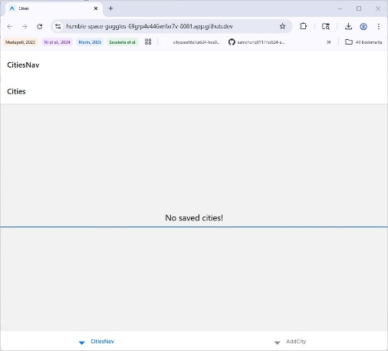
HOS07A: React Native Navigation I

Link:
https://github.com/cityuseattle/cs624-hos07-2026-winter-rghlee.git

Summary:
CitiesApp is a React Native app that allows users to add cities with country names and view them in a list. It uses Bottom Tab Navigator with two tabs (CitiesNav and AddCity). The AddCity handles input and adds a city with a unique ID to the app’s state managed in App.js. The Cities receives the cities as props, displays the city in a list and shows a reusable CenterMessage when the list is empty. The app uses a simple theme.js for shared styling.

